Working with Vectors

a)Generate the following vectors:
A=[1 0 4 5 3 9 0 2]
a=[4 5 0 2 0 0 7 1]

b)Generate the following vectors:
B=[A a]
C=[a A]

c)Generate the following vectors using zeros and ones:
D=linspace(0,0,50)
E=linspace(1,1,100)

d)Generate the following vectors using the colon operator:
F=(1:1:30)
G=(25:-3:1)
H=(0:0.2:2.0)

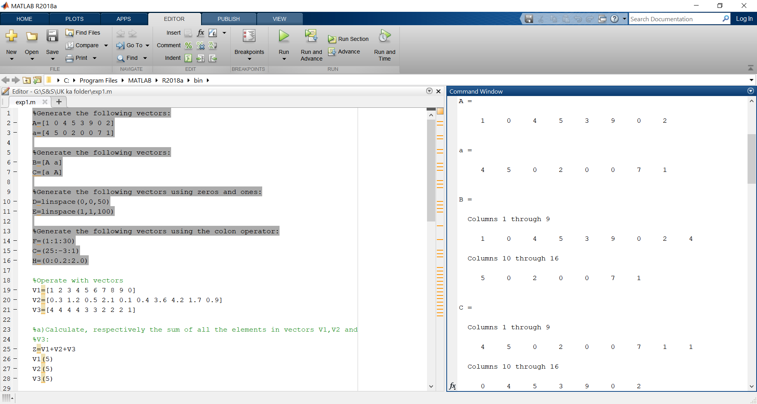
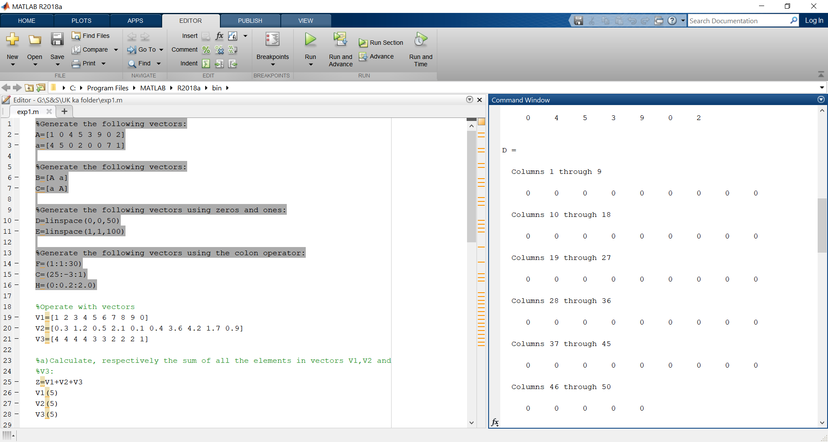

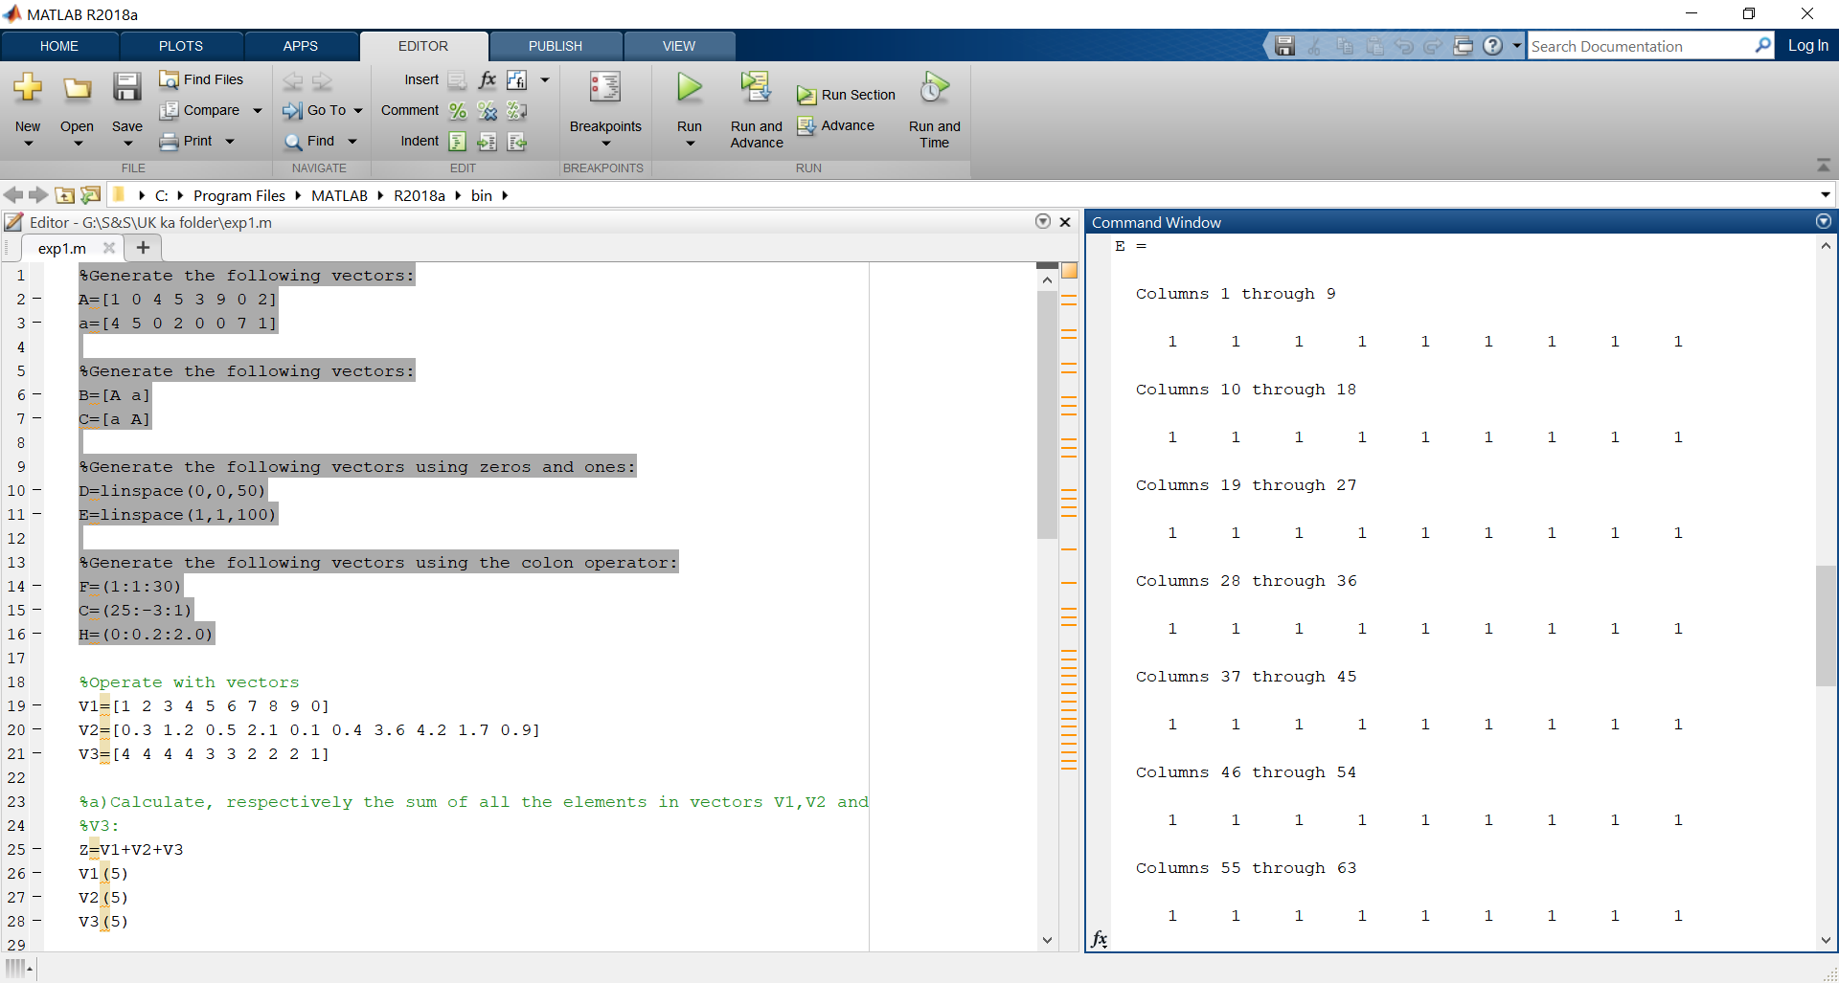
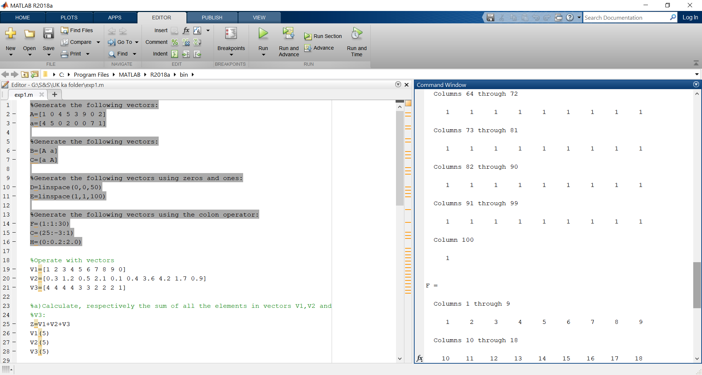
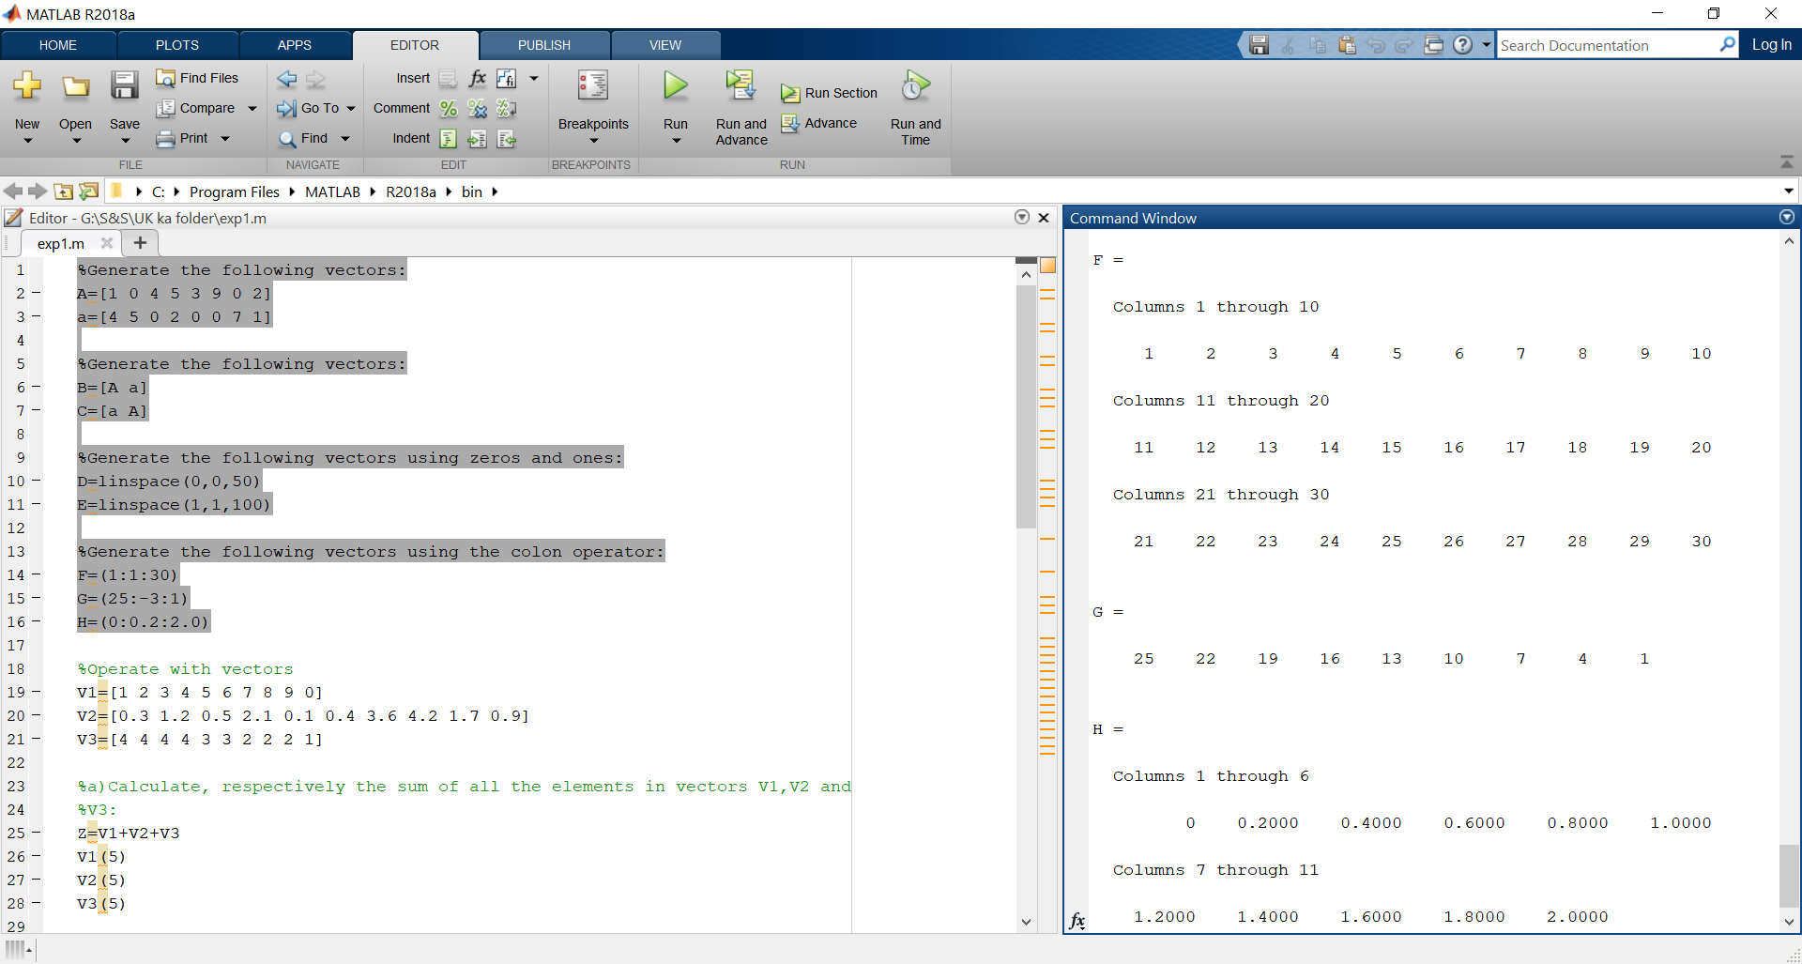

%Operate with vectors
V1=[1 2 3 4 5 6 7 8 9 0]
V2=[0.3 1.2 0.5 2.1 0.1 0.4 3.6 4.2 1.7 0.9]
V3=[4 4 4 4 3 3 2 2 2 1]

a)Calculate, respectively the sum of all the elements in vectors V1,V2 and V3:
Z=V1+V2+V3

b)
V1(5)
V2(5)
V3(5)

c)Generate V4 composed of first fivce elements of V2:
V4=[ V2(1) V2(2) V2(3) V2(4) V2(5)]

Generate V5 composed of last five elements of V2:
V5=[ V2(6) V2(7) V2(8) V2(9) V2(10)]

d)
V6=[V2(1) V2(2) V2(3) V2(4) V2(5) V2(7) V2(8) V2(9) V2(10)]
V7=[V2(1) V2(2) V2(3) V2(4) V2(5) V2(6) 1.4 V2(8) V2(9) V2(10)]
V8=[ V2(1) V2(3) V2(5) V2(7) V2(9) ]

e)WHAT ARE THE RESULTS OF:
Q=9-V1
P=V1*5
R=V1+V2
Q=V1-V3
P=V1.*V2
R=V1*V2
Q=V1.^2
P=V1.^V3
Q=V1^V3
R= V1==V3
P= V1>6
Q=V1>V3
R=V3-(V1>2)
P= (V1>2) & (V1<6)
Q=(V1>2)|(V1<6)
any(V1)
all(V1)

